**Working with Send Email Smart Shape:**

**The way we implemented out bound email ( i.e Password is Visible ) is not a secure way. Before 7 version we can follow this Process.**

**But From Pega 7 Version there is smart shape provided i.e SendEmail shape**

**When using send email it will read Email Id & Password from Integration Out Bound Email/ Integration Email Accounts**

**Configure Out bound Email using Integration Email Wizard:**

**1- Integration -> Email-> Outbound email/Email Accounts ( 1 Account per access group)**

**2- Integration Resources -> Email Account ( More than 1 account we can use this)**

**Add Account using Integration Wizard:**

**From Configure Menu-> Go to Integrations->Email-> Email Accounts**

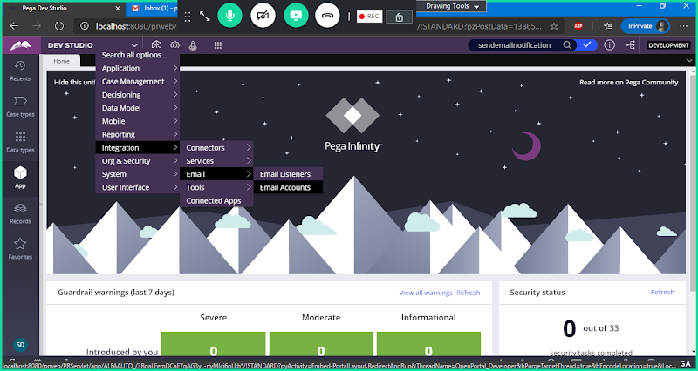

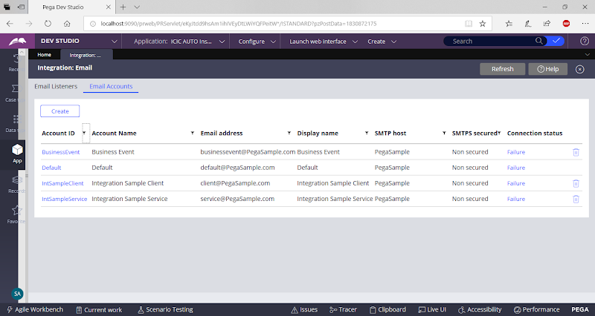

**Click on Create**

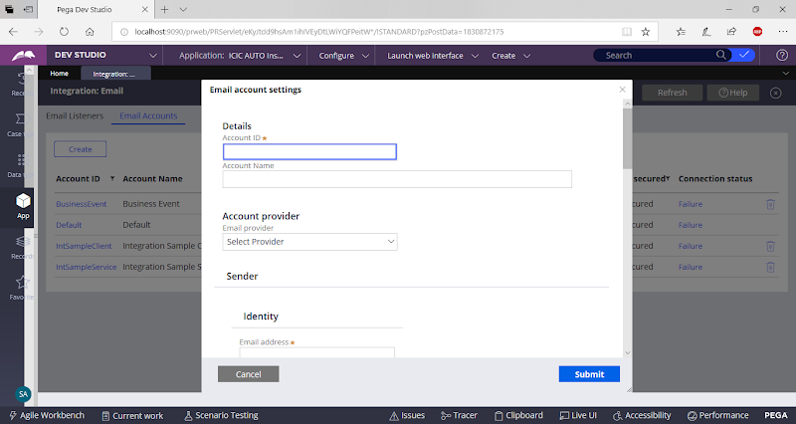

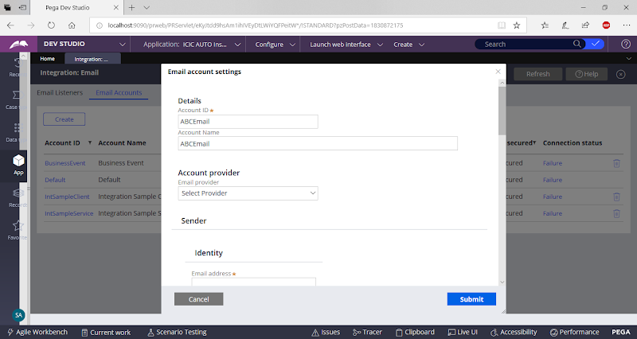

**Select Email Provider**

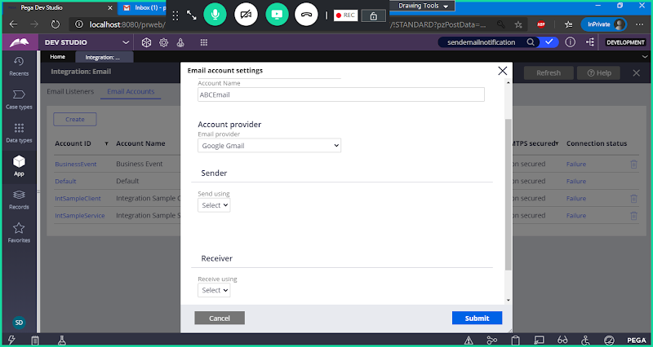

**Under Sender Select SMTP:**

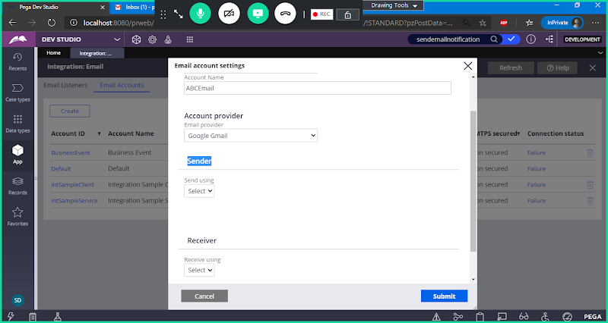

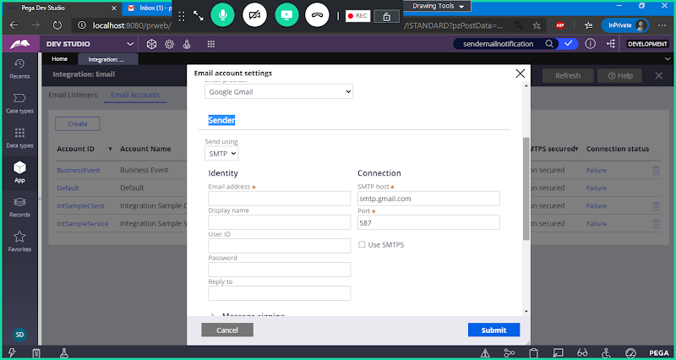

**Now Add Sender Information**

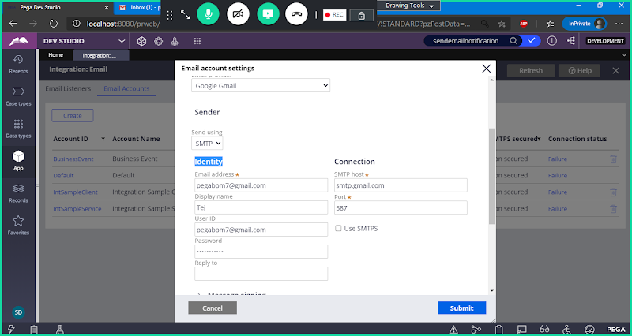

**Now Under Connection:**

**Use SMTPS Connection: Change Port No**

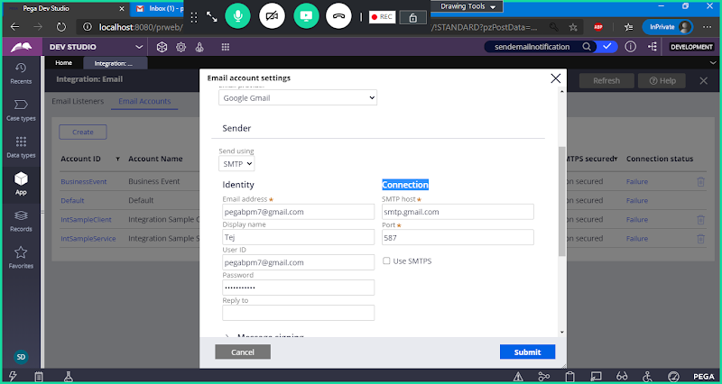

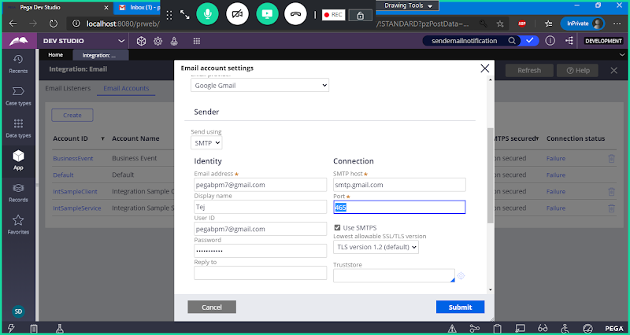

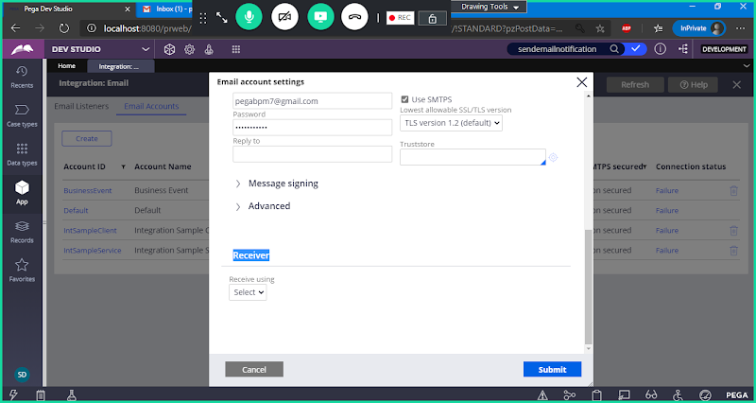

**Under Receiver Select IMAP**

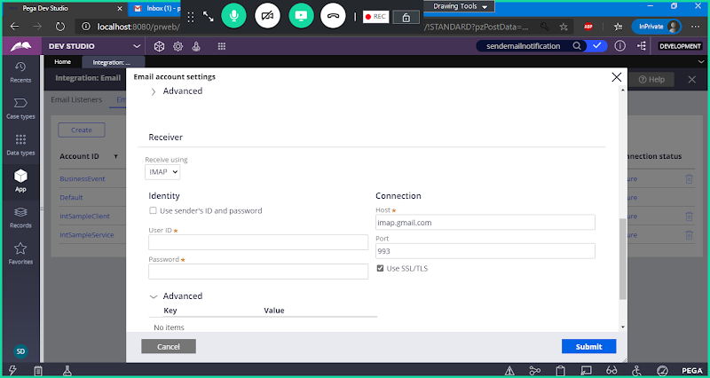

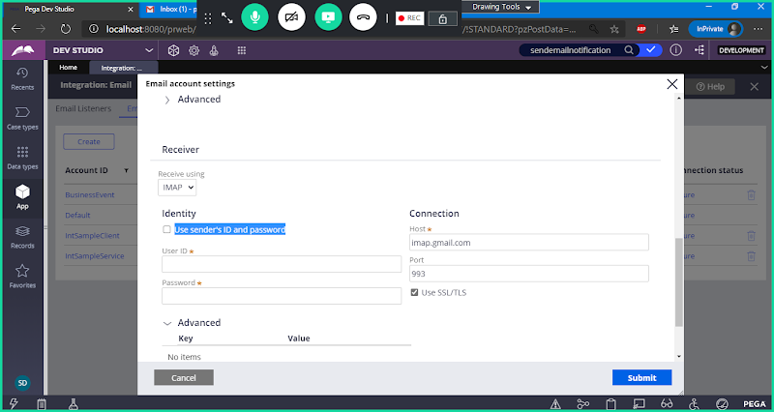

**Now Enable Use Sender's ID and Password**

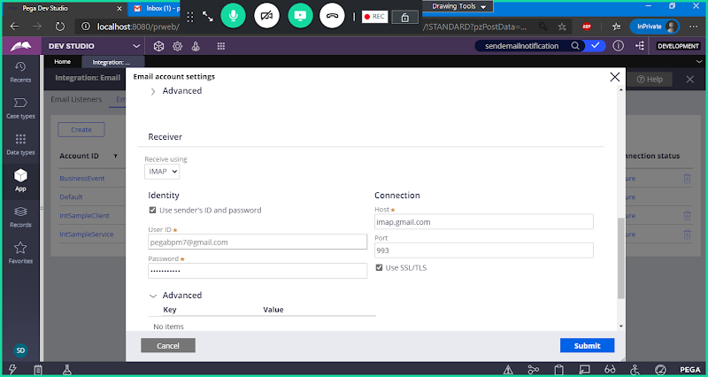

**Submit**

**You should get Success after the connection is added.**

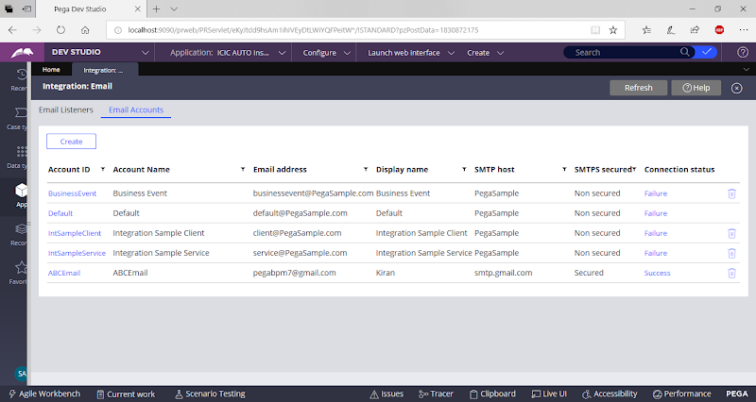

**Create a New Flow:**

**Open Customer Search Flow:**

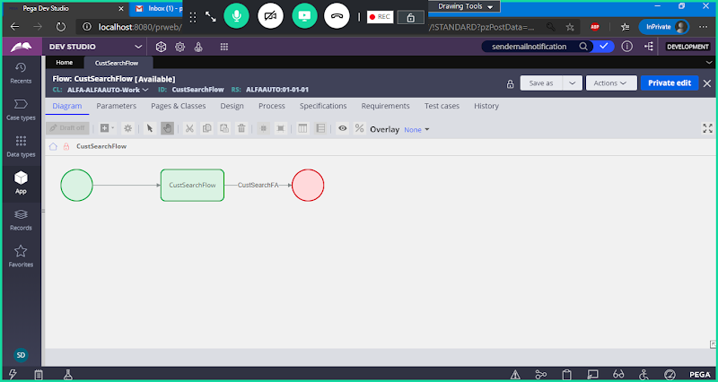

**Add Send Email SMart Shape from Automations**

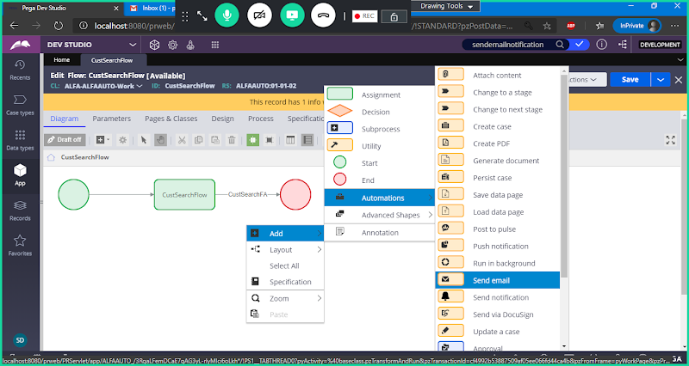

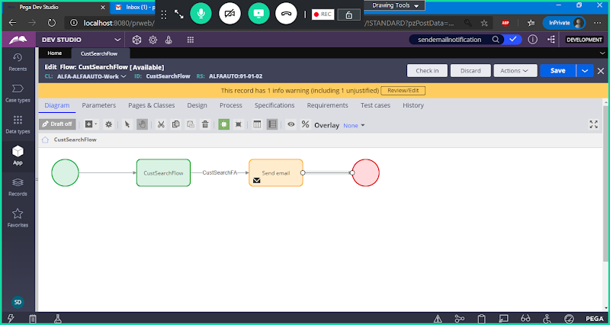

**Double Click on Send email shape**

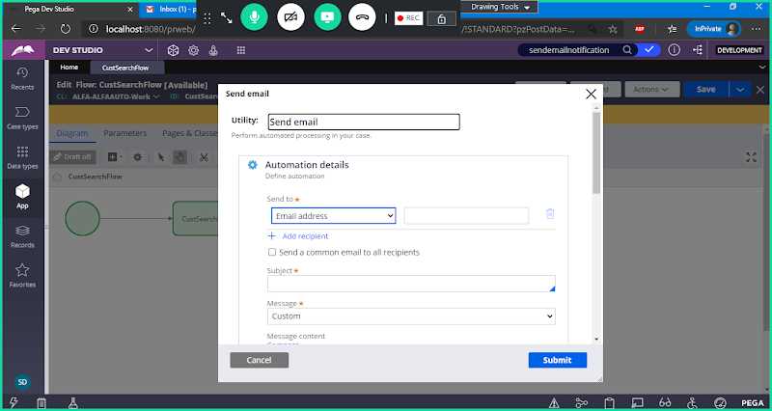

**Select Field under Send to:**

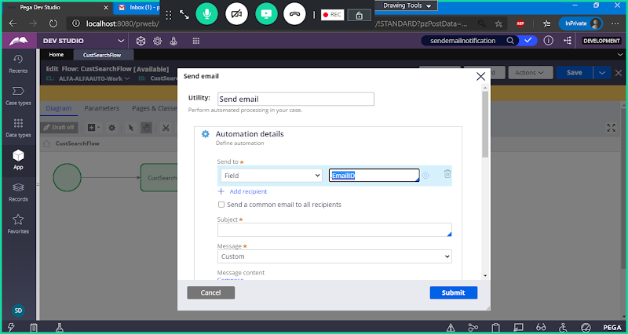

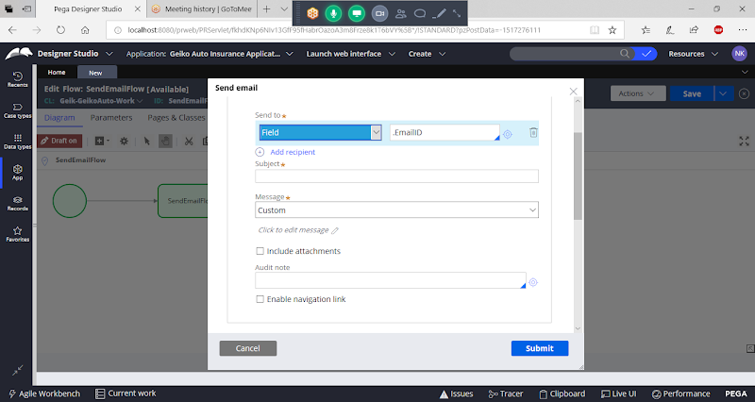

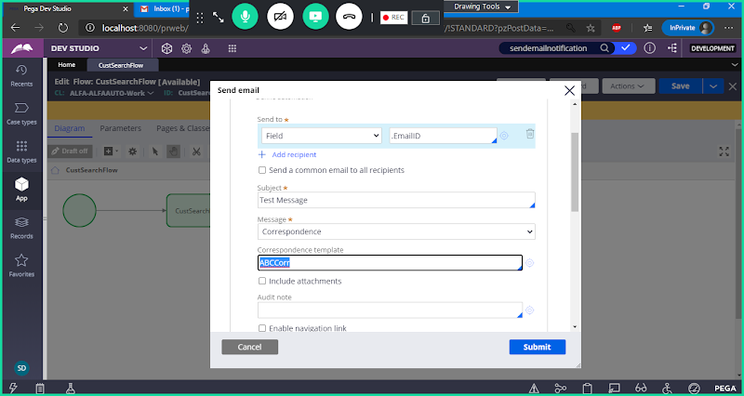

**Submit**

**Save & Run Flow**

**===**

**Also we can add connection using Integration Resources -> Email Account**

